**JQuery**

**TASK -1**

1. Show the working on toggle effect for the following:  
  a. Login Form  
  b. Registration Form  
2. Implement your own ideas to show the working of multiple animate () functionality.  
3. Show the working of animate () functionality with CSS manipulation for the following:  
  a. Change the background of the document.  
  b. Zoom in effect for the div on hover event (change CSS of the contents inside the div element).  
4. Create a simple webpage using the following:  
  a. An accordion with 2 tabs  
      -> Tab 1 - Mobile Phone images (2 images by default), perform jQuery append () to add the mobile images   
      -> Tab 2 - Laptop images (2 images by default), perform jQuery prepend () to add the laptop images  
  b. Show the working of autocomplete to show the list of products.

TASK – 2

Find the attached image for the task.

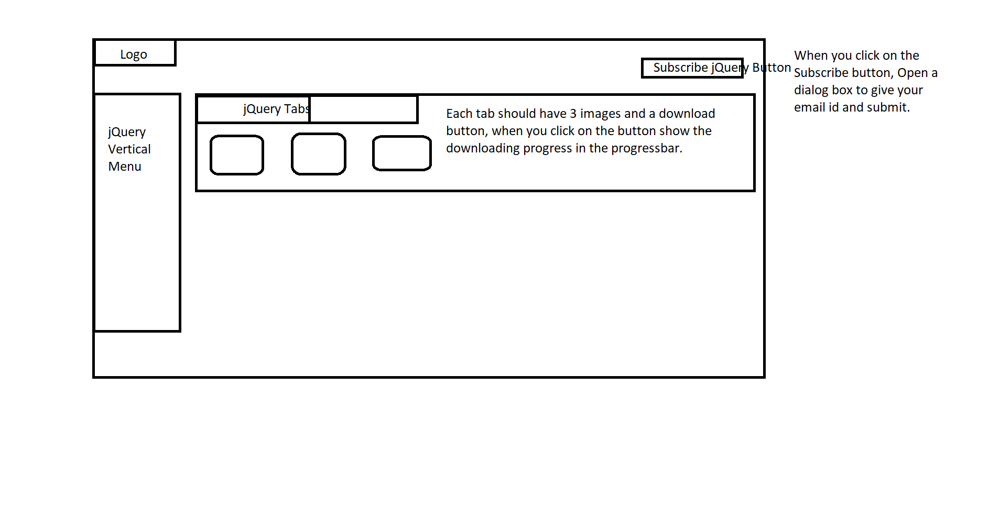

**TASK – 3**

Implement jQuery Validation using Validation plugin for the following:

1. Username - req, minlength, maxlength, pattern (only alphabets)

2. Password - req, pattern (uppercase, lowercase, digits, special characters @$#, minlength-8, maxlength-16)

3. email -req, pattern (email pattern)

4. mobile-req, pattern (3-3-4)

**JQUERY ASSESSMENT**

**I. Use JQuery to perform following validations**

1. To check a password between 7 to 16 characters which contain only characters, numeric digits, underscore and first character must be a letter.

2. Phone number validation format 3-3-4

3. email validation for @cgvakindia.com

**II. Use JQuery to perform following validations**

1. To check a password between 6 to 20 characters which contain at least one numeric digit, one uppercase and one lowercase letter.

2. Phone number validation format 4-3-4

3. email validation for @g2techsoft.com

**III. Use JQuery to perform following validations**

1. To check a password between 7 to 15 characters which contain at least one numeric digit and a special character.

2. Phone number validation format 3-4-4

3. email validation for @cgvak.com

**IV. Use JQuery to perform following validations**

1. To check a password between 8 to 15 characters which contain at least one lowercase letter, one uppercase letter, one

numeric digit, and one special character.

2. Phone number validation format 10-digit mobile number.

3. email validation for @g2tsolutions.com